Common Trouble Shooting: AWS Access Key ID Error and IAM role authority to S3 bucket Error Solutions

I. To resolve the error: The AWS Access Key ID needs a subscription for the service:
First of all, make sure you have your credit card information filled in when you registered. If you had your credit card and phone number available in your account already, try the following:
- Sign in: to the AWS Management Console.
- Navigate to the Billing and Cost Management console.
- Look for an option such as "Upgrade account" to upgrade from a free tier or a similar plan to a paid one.
Then after about 5 minutes, the issue should go away.

II. To resolve the IAM role doesn’t have the authority to access to S3 buckets issue (with error similar to ERROR: S3ServiceException:User: arn:aws:sts::780605917835:assumed-role/AmazonRedshift-CommandsAccessRole-20251002T204251/RedshiftIamRoleSession is not authorized to perform: s3:ListBucket on resource: "arn:aws:s3:::js15441002" because no identity-based policy all Detail: ----------------------------------------------- error: S3ServiceException:User: arn:aws:sts::780605917835:assumed-role/AmazonRedshift-CommandsAccessRole-20251002T204251/RedshiftIamRoleSession is not authorized to perform: s3:ListBucket on resource: "arn:aws:s3:::js15441002" because no identity-based policy all code: 8001 context: Listing bucket=js15441002 prefix=allusers_pipe.txt query: 816169[child_sequence:1] location: s3_utility.cpp:773 process: padbmaster [pid=1073979511] ----------------------------------------------- [ErrorId: 1-68e01d44-55704a1651e36cc607a46941]:)
- Go to your Namespace:
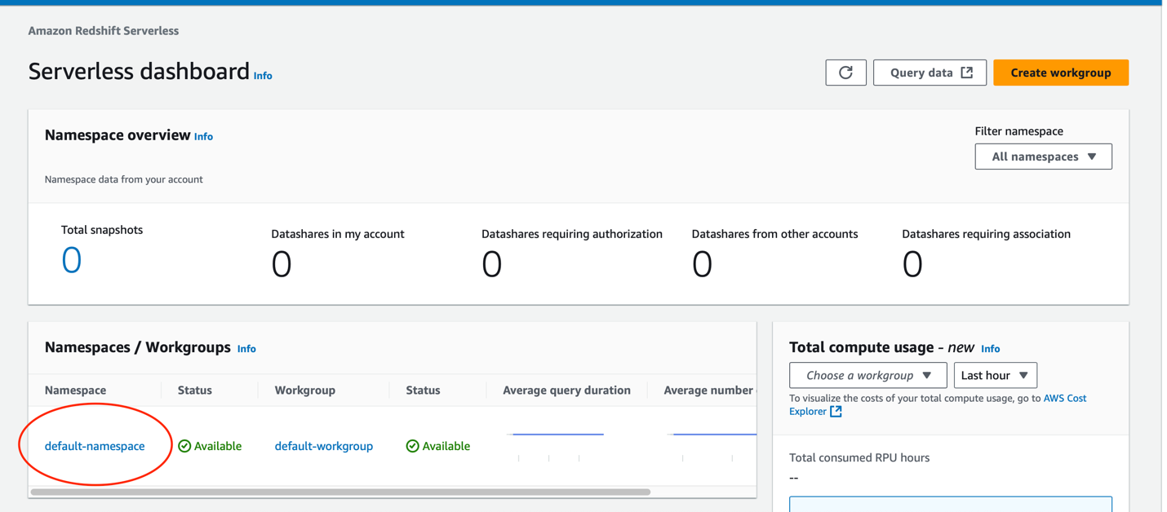

- Under the Security and Encryption, find and select IAM role:
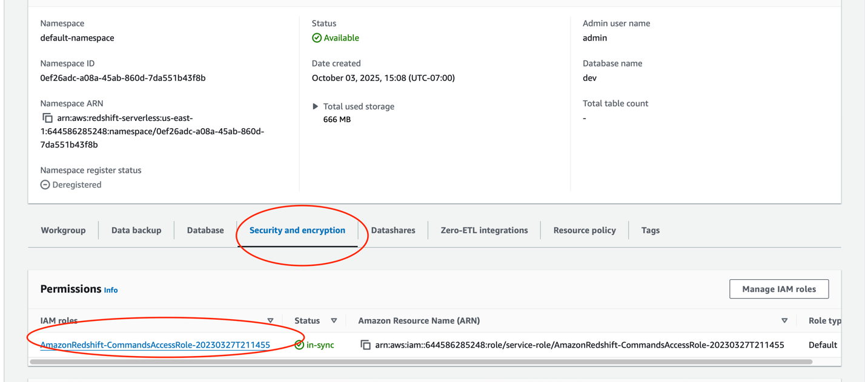

- Add Permissions: Attach Policies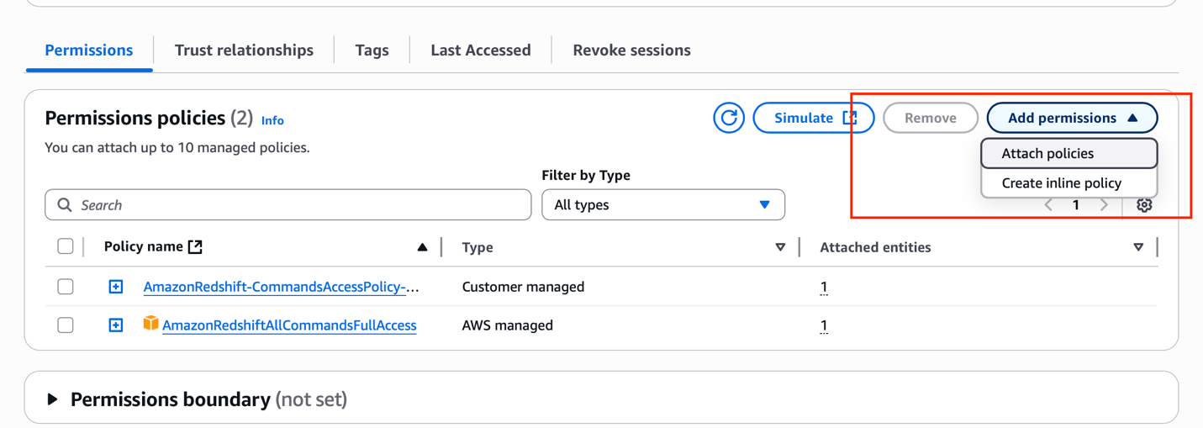
- Search for S3 roles, and add them all just in case:
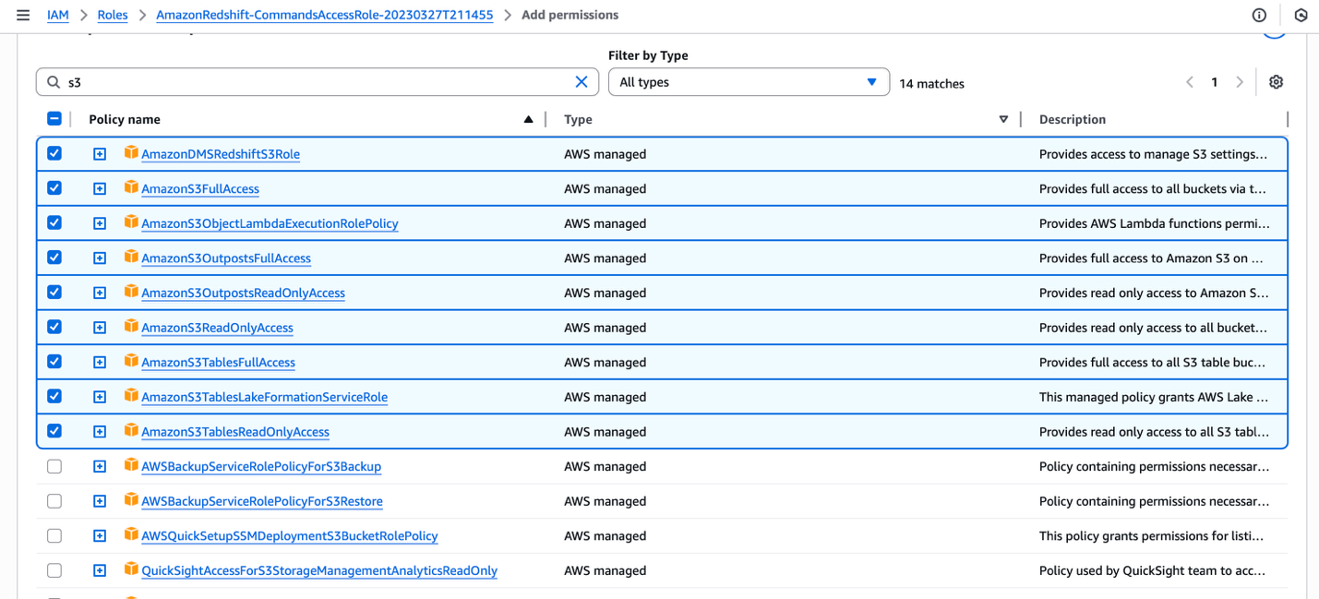

Add permissions
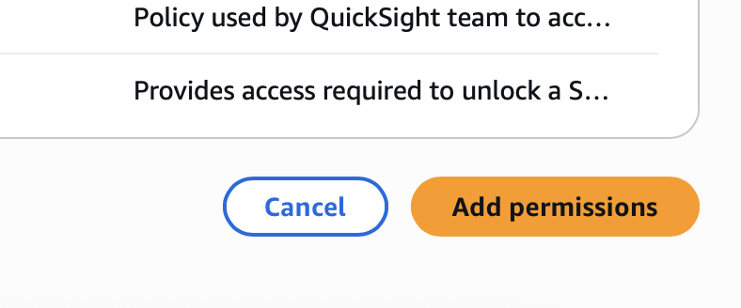

- Go back to your editor, refresh and run the copy query again;

